Student Field Experience Binder Instructions

Introduction
One of the requirements for successful completion of your field experience is to submit (by the deadline) a group of required forms in a “Field Experience Binder” inside your Tk20 account.

Accessing Your Field Experience Binder
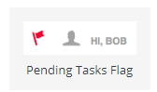
Once you are logged into Tk20, you can locate your Field Experience Binder in three different ways:
- Click on the flag icon at the top right of your screen or
- click on the link for your binder under the PENDING TASK section of your home dashboard or
- click on the FIELD EXPERIENCE link in the left side menu

Viewing Your Field Experience Binder
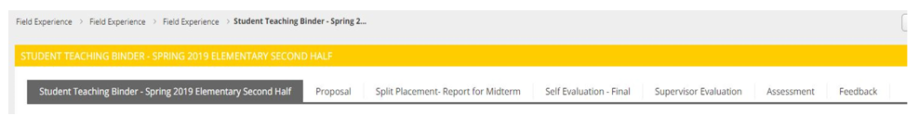
Your binder will have a number of tabs (described from left to right)
- ONE Field Experience Binder cover tab. You’ll see the title and additional general information (including deadlines) for your binder.
- ONE or MORE sub-tabs (just to the right of the cover tab. Each of these tabs present instructions, deadlines, and online forms that you (the student) must complete. Your sub-tab titles may vary.
- ONE assessment tab and ONE feedback tab (last two tabs, far right). These tabs are used by evaluators. There are NO TASKS for you (the student) to complete under these two tabs.

Completing the Forms in Your Field Experience Binder
- Click on any sub-tab (excluding assessment and feedback) to the right of the Field Experience Binder cover page. (Tab title will vary.)
- Click on the SELECT BUTTON to the right of a form’s title (under Attachments) to open the associated form. Your form titles will vary.
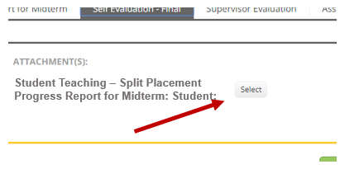
- Complete all of the fields in the form. Do not attach additional documents.
- Click the green ADD button at the end of the form (bottom, far right side of the page).
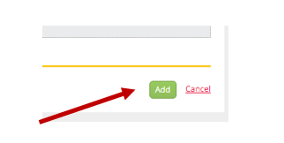
- You will be returned to the sub-tab page you were on.
  - If you are ready to submit the form, click the SUBMIT button at the bottom right of the sub-tab page. You may not be able to submit until ALL forms in the binder are completed. In this case, you will SUBMIT at the end of the field experience when all forms are complete.
  - If you need to save your work to complete later, click SAVE.
  - Be sure you SUMBIT the sub-tab by the due date if indicated (listed on the cover tab).
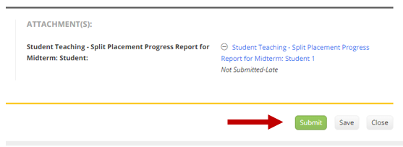
- Repeat steps 1-5 for each sub-tab until all forms have been completed and sub-tabs have been SUBMITTED.
  - Remember, the assessment and feedback tabs are used by evaluators. There are NO TASKS for you (the student) to complete under these two tabs.

Submitting Your Completed Binder
When you’ve completed all of your online forms, your final step is to submit your binder
- Access your Field Experience Binder (from your pending tasks or Field Experience menu link)
- Click on your Field Experience Binder cover tab. Your tab names may vary. The cover tab is the first one on the left.
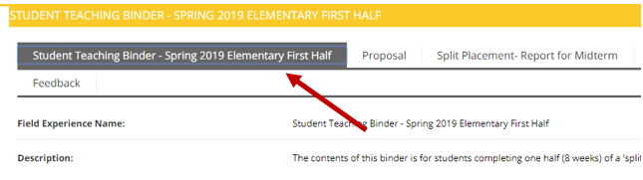
- Click the SUBMIT button at the bottom of that page.
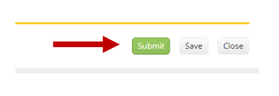
- You’ll see a pop-up window that lists all of the forms in your binder. Click the checkboxes to select all of the forms and then click SUBMIT at the bottom of that pop-up window.
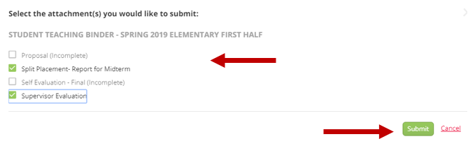
- NOTE: If a form title is gray and you cannot click in the checkbox, this means you did not complete the form. You’ll need to return to the appropriate tab, and return to the instructions (above) for completing a form. You may also receive a message if any form has empty fields.
- When all of your forms have been submitted, the status of your binder will show Completed and a lock will appear next to the binder title.
